North Lincolnshire Council
Daily Event Analysis
14th January 2011

Overview

The Dawes Lane Coke Oven (DLCO) Osiris measured a daily mean PM₁₀ concentration of 54µg/m³ on Friday 14th January 2011 exceeding the allowed 50µg/m³ as a daily mean. The Low Santon TEOM measured a daily mean concentration of 60µg/m³ also exceeding the allowed 50µg/m³ daily mean.

A check of the data has revealed elevated concentrations of PM₁₀ between 10:00 and 13:30 at the Low Santon TEOM. During this period the Low Santon TEOM measured a mean concentration of 106µg/m³ and the DLCO 44µg/m³.

Met Conditions

Consistent South Westerly winds were recorded throughout the day. The wind within the 3 hour 30 minute period of focus ranged between 216° and 229°. Wind speeds averaged at 2.7 m/s for the day.

Episode Wind Range
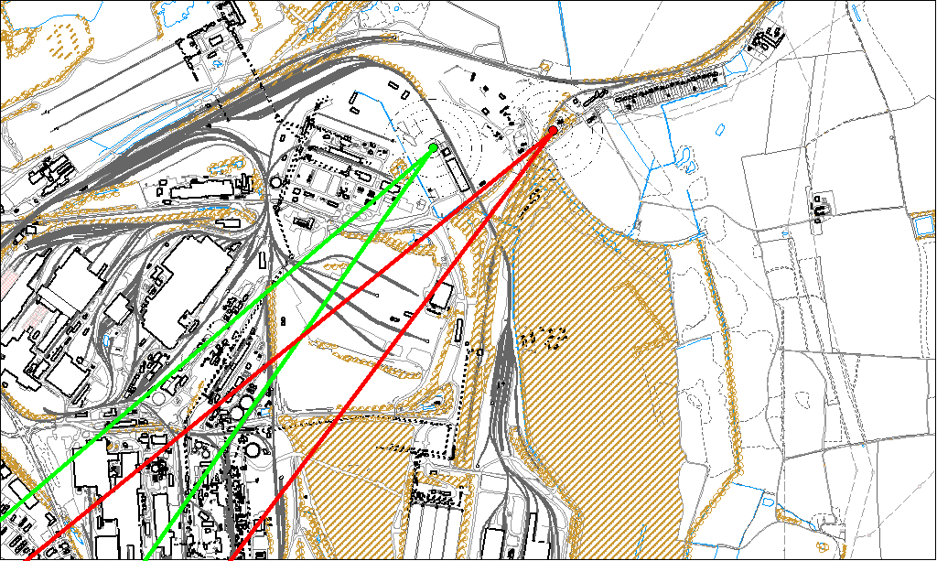

Potential Sources

The above map shows the Low Santon TEOM (indicated by the red lines) and the DLCO Osiris (indicated by the green). As only the Low Santon TEOM measured consistently higher concentrations during the period of focus, it is likely that they were affected by a different source at this time. Therefore, the area within the red lines is likely to contain the source. It should be noted however that both monitors exceeded the daily mean.

The likely areas include;
- Redbourn site
- Intermediate site

